Worksheet 7 'New York, New York!'

My trip to New York!
You're going to New York with your school. You all have a penfriend. You'll spend a week at your penfriend's house. Before your departure, she sends you an e-mail in which she describes her bedroom. Her parents are very rich and she lives in a huge house!
Using all what we've done, write her e-mail.

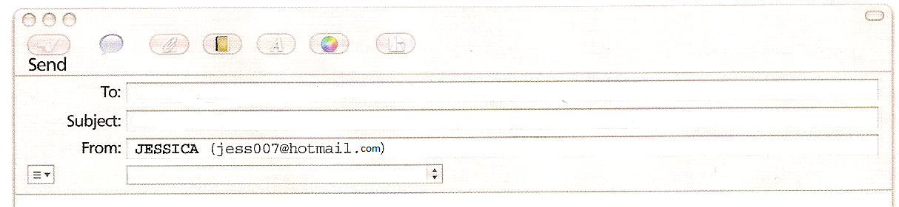
Dear penfriend,
My name is Jessica. I'm American. I'm from New York.
My bedroom ….......…......................................................................................................................
….............................................................................................................................................................
….............................................................................................................................................................
….............................................................................................................................................................
….............................................................................................................................................................
….............................................................................................................................................................
….............................................................................................................................................................
….............................................................................................................................................................
….............................................................................................................................................................
….............................................................................................................................................................
….............................................................................................................................................................
….............................................................................................................................................................
Fondly, Jessica.

