Name: How to describe a bedroom Class:

Compréhension orale | …..... / 10
Expression écrite | …..... / 10

1. The O'Kellys' bedrooms: (10 points)
Mr O'Kelly has got two children, Mary and Patrick.
Listen to Mr O'Kelly describing their bedrooms.
Complete each bedroom.

Mary's bedroom Patrick's bedroom
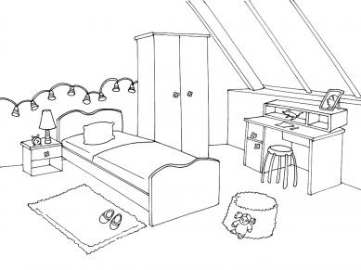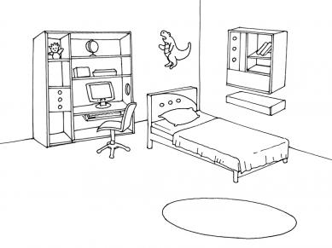

2. Mike's bedroom: (10 points)
For his English class, Mike must describe his bedroom.
Help him to complete his homework! Be as precise as possible!
Bonus + 2 pts: I did my best to describe this bedroom.
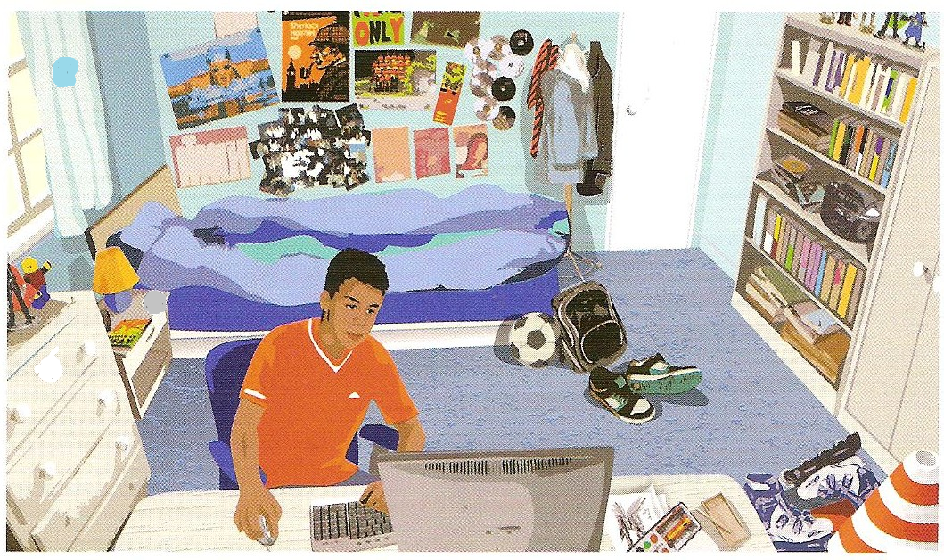

My bedroom ….........................................................................................................................................................…..................................................................................................................................................................................................................................................................................................................................................................…..................................................................................................................................................................................................................................................................................................................................................................…...............................................................................................................................................................................

