Christmas day

Every year Christmas is the same or nearly the same and this why we all like it. Christmas is a great celebration. All people have Christmas. Every family has its own rules for this special day. They are nearly the same in every family in Slovakia.

We get up late. We don’t have breakfast and lunch, because it is fasting, we sit in front of television and watch some cartoons, fairytales and films about Christmas. Out mother so far is in kitchen and she cooks Christmas dinner.
Typical Christmas dinner is potatoes salad whit fried chop and fish and sour court soup. While our mum cooks dinner we decorate our Christmas tree. When we finish our work, all family sits in front of television. Then we go set the table and in the middle of the table there is a plate with tree apples. Then we go to the church. Later we go to cemetery to light candles. When we go home, we go to the kitchen and we eat Christmas dinner. After dinner we have a drink. Then visit our grandmother and godfather and godmother and there we pond presents.
Then we watch television and we go to our bed and Christmas day is away.

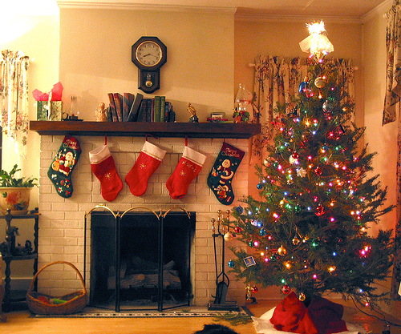

Katka, Dominika, Mariana 2.A

