Recipe CAKE FOR TWELFTH NIGHT

- INGREDIENTS
  - Repeat the following words , then guess what ingredients we need to make this cake.

Water oil cream apples orange blossom water salt bananas butter

Cheese eggs chocolate vanilla vanilla sugar flour yolk sugar wine

Match the ingredients with their measures

*tbsp = tablespoonful

1 glass ● ● butter
12 lumps ● ●water
150g ● ●orange blossom water
3+1 yolk ● ●vanilla sugar
60 g ● ●sugar
1bag(=sachet) ● ● flour
4tbsp ● ● cream
1 small tin(=pot) ● ●salt
1 pinch ● ●eggs

- UTENSILS : Circle the ones we need.

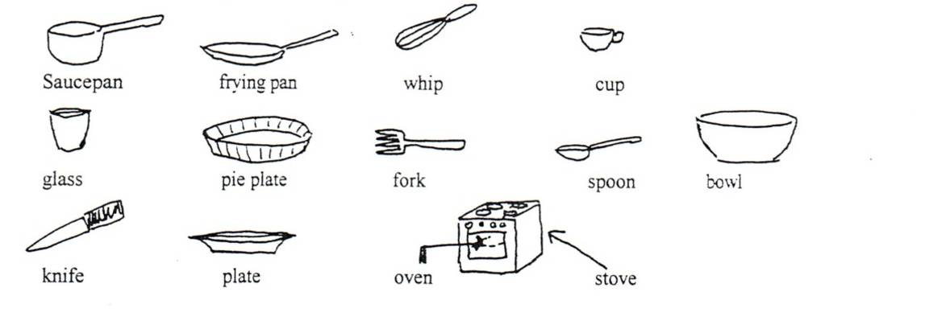

- Method: Listen and put the sentences in the correct order.

    - Put the dough into oven and bake for 30 minutes.
    - Quickly sieve the flour into the pan and whisk together with the liquid ingredients.
    - In a small bowl, mix yolk, vanilla sugar and 1 tbsp cream.
    - Remove from the heat,
    - Preheat oven to mark 7 (200°c)
    - Add eggs one at a time, beating well ( 2 mins each), then add cream ( ¾ tin)
    - Top the dough with this mixture.
    - Put water, orange blossom water, butter, sugar and salt into a saucepan.
    - Put the dough into a pie plate.
    - Heat till boiling.
    - Keep stirring until the paste clumps together in a smooth ball.
Now, you can make this cake! DON’T FORGET THE CHARM!!!
Activité proposée par Liseby Guy, Collège Voltaire, Besançon. Liseby.guy@ac-besancon.fr

