Recipe CAKE FOR TWELFTH NIGHT correction

- INGREDIENTS ( faire répéter et noter la phonétique)
  - Repeat the following words , then guess what ingredients we need to make this cake.

Water oil cream apples orange blossom water salt bananas butter

Cheese eggs chocolate vanilla vanilla sugar flour yolk sugar wine

Match the ingredients with their measures

*tbsp = tablespoonful

1 glass ● ● butter
12 lumps ● ●water
150g ● ●orange blossom water
3+1 yolk ● ● vanilla sugar
60 g ● ●sugar
1 bag(=sachet) ● ● flour
4tbsp ● ● cream
1 small tin (=pot) ● ●salt
1 pinch ● ●eggs

2)UTENSILS: Cirle the ones we need.

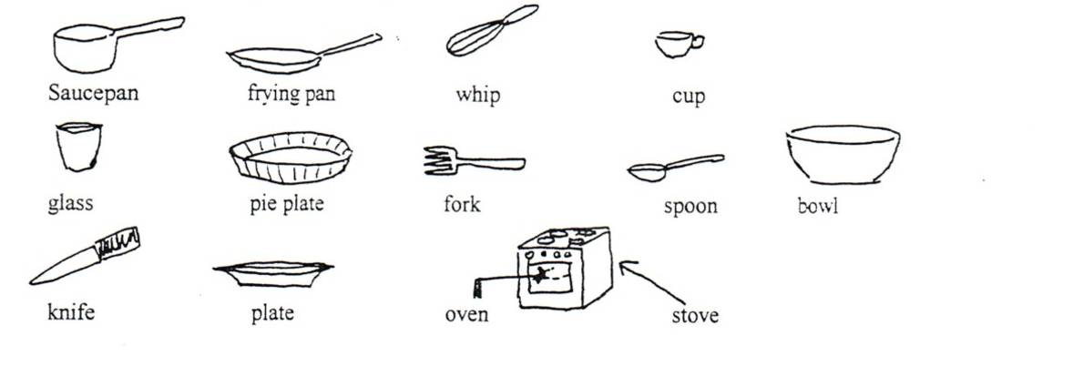
utensils: saucepan /whip / glass / fork / spoon / bowl / pie plate /stove / oven
- Method: Listen and put the sentences in the correct order.

    - Preheat oven to mark 7 (200°c)
    - Put water, orange blossom water, butter, sugar and salt in a saucepan.
    - Heat till boiling.
    - Remove from the heat,
    - Quickly sieve the flour into the pan and whisk together with the liquid ingredients.
    - Keep stirring until the paste clumps together in a smooth ball.
    - Add eggs one at a time, beating well ( 2 mins each), then add cream ( ¾ pot)
    - Put the paste into a pie plate.
    - In a small bowl, mix yolk, vanilla sugar and 1 tbsp cream.
    - Top the dough with this mixture.
    - Put the dough into oven and bake for 30 minutes

Now, you can make this cake! DON’T FORGET THE CHARM!!!
Activité proposée par Liseby Guy, Collège Voltaire, Besançon. Liseby.guy@ac-besancon.fr.

