Phoning the Estate Agent

Listen to ( ) the dialogue and complete (…) with the missing words.

Lindsay and Pat are phoning an estate agent for a new flat:

Lindsay: Is there a large __________________?

Estate Agent: No, there isn’t. There’s only a very small _______________.

Lindsay: Are there two _______________?

Estate Agent: Yes, there are. There are two _________________.

Lindsay: Good! And is there a large _______________?

Estate Agent: Yes, there is. _____________ a large _________________ and a small lounge.

Lindsay: Are there two ___________________ in the flat?

Estate Agent: No, there aren’t. There’s only one ________________ with a shower.

Lindsay: Yes. And where is the __________________?

Estate Agent: It’s in the _______________ too.

Lindsay: Is there a ______________ for our car?

Estate Agent: No, sorry. There is no ______________. But there is a large car park _______________ the ________________.

Lindsay: That’s nice. Are there any ______________ in the street?

Estate Agent: No there aren’t any _________________ in the street, but there is a supermarket nearby and there are some _______________in Market Street.

Lindsay: ___________ ___________, can we visit the flat?

An estate agent



A flat
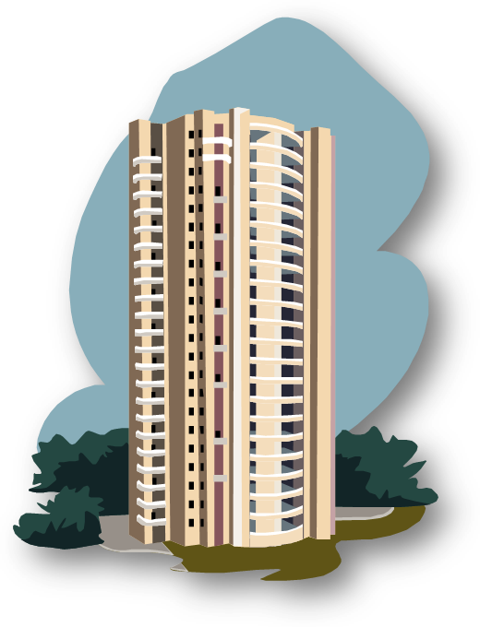
A building

A shower

