ENGLISH TEST
January 2015 NAME: __________________________________________ /20

- Describe this document and interpret it. Is it good propaganda? Why? /17

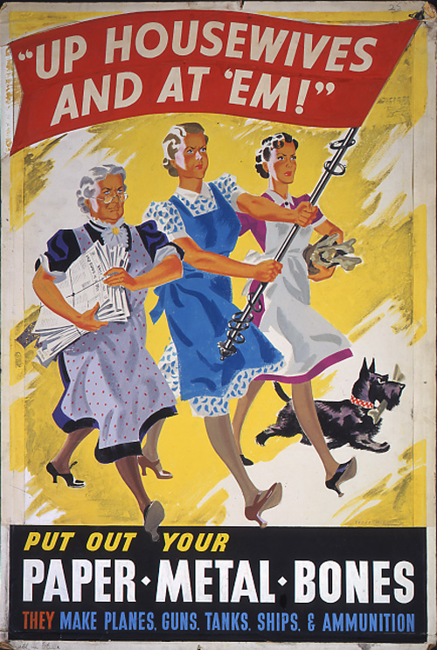

- Explain in French: /3
“The advice to GIs was that the Tommies could be touchy about their higher wages.”

_____________________________________________________________________________________________________

_____________________________________________________________________________________________________

ENGLISH TEST
January 2015 NAME: __________________________________________ /20

- Describe this document and interpret it. Is it good propaganda? Why? /17
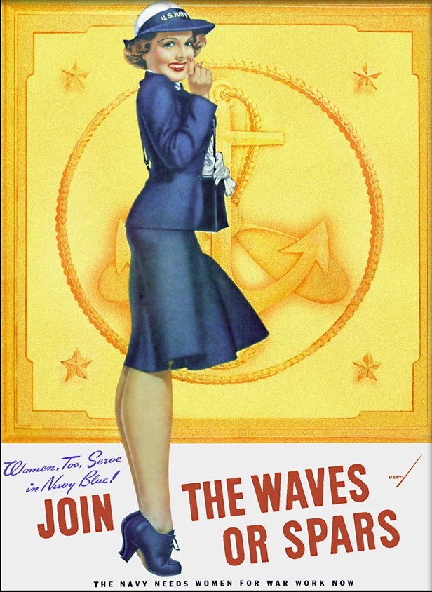

- Explain in French: /3
“To GIs, the tough attitude of the brits was surprising because they were such a soft-spoken people.”

_____________________________________________________________________________________________________

_____________________________________________________________________________________________________

