ENGLISH TEST January 2015
NAME: __________________________________________ /20

- Describe this document and interpret it. Is it good propaganda? Why? /17

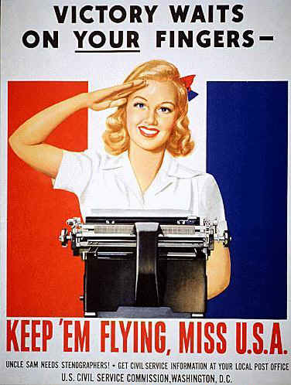

- Explain in French: /3
“The advice to GIs was that the Tommies could be touchy about their higher wages.”

_____________________________________________________________________________________________________

