Tâche finale
jeu de rôle : Gis and British girls
Jouer un saynète improvisée à partir d'une situation donnée sur des cartes de situation. Le but étant de faire passer les informations notées sur les cartes.

Validations
Mise en oeuvre
Comp orale : US advice to servicemen in Britain + deux vidéos d’époque sur le Blitz à Londres (une propagande, l’autre montage moderne)
Comp écrite : lecture texte Overpaid, fiches de jeu de rôle
Expr Orale : (en cours) mise en commun d’idées, tâche finale jeu de rôle
Expr Ecrite : évaluation écrite description et interprétation personnelle d’un poster de propagande

Evaluations
oral : jeu de rôle
écrit : décrire une affiche
Élément déclencheur: Women’s Land Army poster
Pour réaliser la tâche finale, voici les outils dont mes élèves ont besoin, déclinés en termes d'objectifs
Linguistiques |  |  |  | Méthodologiques  décrire une image  interpréter les choix artistiques/ de propagande (sous forme argumentée d’après modèle rigideélaboré en classe)  se préparer à un jeu de rôle  Être capable d'évaluer la prestation d'un camarade à partir de critères précis. | Communicationnels  Jeu de rôle (interaction libre mais encadrée au niveau individuel  Savoir donner des conseils et suggérer des solutions | Culturels  world war II in Britain  American Gis  Life in London during the war  Blackout  Position and options for young women at the time
Lexicaux |  | Grammaticaux | Phonologiques
Farming  Propaganda  Town life  Everyday objects/ actions in the 40s  Army vocab  Courting etiquette 40s  (Rebrassage cooking) |  | Passif  were told/advised to… WERE INFORMED THAT…  sentence builders  modaux conseil/suggestion | Travail de comp orale accents US et British RP  Travail d’intonation et pron à l’oral
Mise en œuvre de la séquence
1 | Anticipation et mise en contexte historique : Women’s Land Army poster  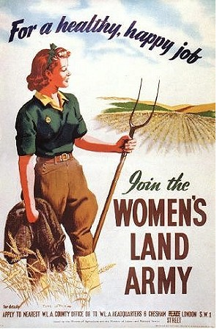  pairwork: prepare the description (5 minutes)  re-use technique from Rockwell  mise en commun classe oralement  document commun à coller  Introduction  This is a WW II propaganda poster enticing women to join in the war effort in the UK.  Description  There is a caption at the top of the poster stating the objective: being healthy and happy.  The picture is separated between a young lady on the left and a landscape on the right. She is wearing a green and brown uniform and holding a pitchfork. Her hand is at the center of the poster. She occupies a lot of space on the poster. She is in the countryside. Her feet are in wheat and she looking to the right of the picture where the fields and the horizon are.  On the bottom right is the message: join the women’s land army.  At the very bottom we can see some practical information (contact name and address).  Interpretation:  The fact that all the colours used in the picture are in the blues, greens and browns gives/implies a sense/idea of nature (blue for the sky; green and brown for the land). Nature appears idealized, so does the lady: they are selling an ideal of health and happiness in a time of war hardship. Town people were suffering greatly from the war and this poster must have attracted many women. The actual farm work is at the center of the poster but from the general look we can infer that it looks easy and clean and not too difficult (the lady doesn't look very strong). The fact that she is looking to the right symbolizes looking to the future in a positive way.  The word army reminds us that it is wartime otherwise it looks like a job advert.  Conclusion:  I think it is / is not effective propaganda because…  HW : learn new words + sentence builders :  The fact that she is looking to the right symbolizes/ gives a sense of looking to the future.  From the written information, we can infer that this is a propaganda poster
2 | DON’T FORGET docs  Start quick check vocab is learnt  Blitz video 1 : London Can Take It [1940#2BC200  to 5.06 sans sous titres  orally : what info / personal impressions ?  what type of doc ? propaganda  what images are chosen to what effect ? :  every day life / ordinary citizens/office workers  sleeping through the bombing (!)  importance of the fire fighters not the fires in the frame  watch again to 5.06 with subtitles to the end  what does the voiceover add?  SOUND :  solemn and calm tone, US accent  RHETORIC :  poetry of repetition and soft slow solemn tone (respect/ resignation/ distance ?)  understatement visitors/ Jerry is late tonight / not a pleasant…  oxymoron / irony civilian army  personification when speaking of London ‘she’… ‘dressed for battle’ … brushing from her hair….  noticeable ommissions/ dissimulation?  no people trauma/ blood/ wounded / dead / mutilation (the only wounded is the cat !) only buildings, infrastructure andand ressources  the allies don’t bomb civilians…  no emotive language/images  message title: London can take it / ‘the morale is higher than ever’  CONTRAST WITH AMATEUR Blitz video 2 : London Blitz - YouTube.webloc  Differences between both documents…  TE During the war, propaganda films were produced, one of which is 'London can take it'.  It shows Londonners before, during and after a night raid. The general atmosphere /feel/tone is solemn, calm and detached. The rhetoric and the image/music combo are all ironic: oxymorons (ex: civilians' army), understatement (ex: they might kill a few people', 'our nightly visitors', 'not very pleasant')  The only casualty shown is a lucky cat pulled from the debris!  We feel a gap between images/tone/language and the reality of war. The message is clear: Londonners have fantastic morale!  HW : (différencié) hand out laminated replicas (more or less text)  study this document and prepare to describe it to the class in a couple of sentences next time.
3 | Oral : choose the best able students to describe their docs and every time ask who has another with the same theme. ‘I also have a ration book!’ ‘Mine is about gas masks too !’ etc…  type of document + function + message  TE We saw three different types of documents:  Propaganda: leaflets and posters trying to convince people to join the war effprt: let your children evacuate, cultivate/grow vegetables (dig for victory) or save cooking fat.  Information: many documents were printed to teach people good security gestures and actions: how to put on a gas mask or recognize/ditinguish between the various symptoms after a raid.  Photographs of actual objects: ration books, box of dried eggs or a minute/tiny bar of chocolate
4 | COMP ORALE : worksheet  Description en voix passive (met en première place l'objet de l'action. Elle est construite avec Be conjugué suivi du participe passé du verbe.)  TE : In this document, advice is given to American soldiers who came to England during World War II.  American soldiers were told not to be show-offs because they were highly paid in comparison to the British Tommy.  They were told to be respectful.  They were told that there were many similarities between the USA and Britain.  British people are presented as tough and strong people with an unbreakable moral. They are presented as good allies.  This document aims to help the soldiers better understand the English culture and to consider the British as allies.  TIME TO FILL IN TITLE PAGE : Gis and British girls  Explain tache finale : role play  COMP E overpaid, oversexed, overhere  Anticipation titres+photos  Hw : read the text and do worksheet
5 | COMP E overpaid, oversexed, overhere  TE : en classe  What advice could we give Gis if we met them ?
6 | Entrainement role play  Révision de l’utilisation des modaux : what should you do ? What’s your advice ? what do you advice me to do ?  you should / you must / you ought to... you have to ...you might .. you could... you need to … you would  show ‘advice slideshow’ on OHP about issues to do with the black out/ rationing/ position of women  students orally give advice  example :  if you want to help your country/defeat the ennemy/save energy/ save food… you should not waste it/ you must join the WLA/ ….  TE :  If your friends were told they should(n’t) …. Would they ?  If your sister was advised she ought (not) to …. Would she ?  Homework : hand out role play cards  (différencié : donner le groupe pour les moins habiles (Lola, Loise, Nathan, Benoit, Louis, Emma), qu’ils puissent préparer ensemble pour anticiper les interactions)  start thinking of what to say + revise all the info / vocab / sentence building tools from your lessons.  To be performed next week ! prepare individually
7 | Test intermédiaire (you can use your copybook and a dictionary)  Describe and analyse one of the poster of your choice
8 | Correction  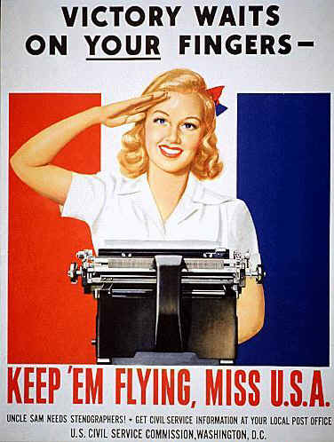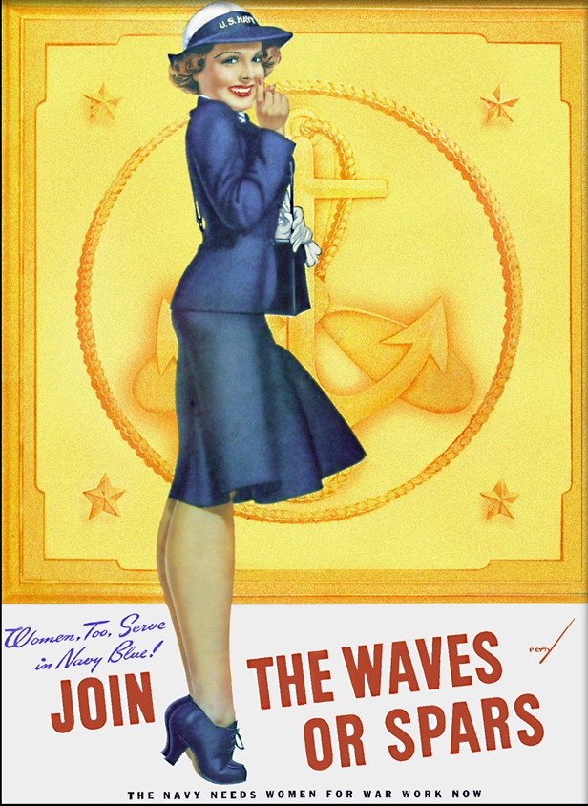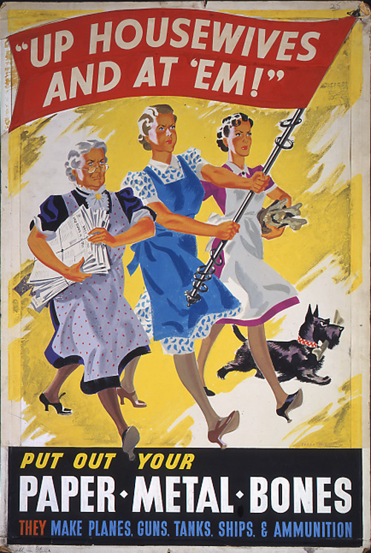
9 | TACHE FINALE Roleplays  DRIED EGGS  Shopkeeper: OLIVE SMITH (single, 28 years old)  GI#1 NAME: TOM GREEVES (20, from NEW YORK CITY, peacetime job: greengrocer)  GI#2 NAME: LUKE TREGASKIS (31, LOS ANGELES, professional baseball player)  WOMEN'S LAND ARMY  BRITISH GIRL #1 NAME: MARY ALDERMAN (single, 22 years old)  BRITISH GIRL #2 NAME: HELEN ATWOOD (single, 21 years old)  GI NAME : ANTHONY ABRUZZO (single, 25 years old, from Little Italy in New York City)  BLACKOUT PAINT (+ able)  BRITISH GIRL NAME: MAUREEN PHILLIPS (19 years old)  GI NAME: GREG MACKENZIE (20 years old, from Chicago, ILLINOIS)  GAS MASK PRESENT(+ able)  SHOPKEEPER: MAUD STEVENS (35 years old)  GI NAME: LEROY BROWN (22 years old, from DENVER, Colorado)  GIRL NAME: DOROTHY O’CONNOR (24, work as a secretary. Lives alone.)  Note prof/15  Note élèves/5

