  ex. Betty’s pants **are** like Lisa’s because **they** are tight. Betty Lisa



Singular or plural? The verb changes **(is/are)** and the pronoun changes **(it/they).**

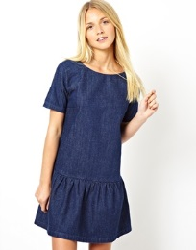  …………………………………………………………………………………

Lucy Charlotte …………………………………………………………………………………

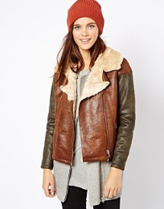 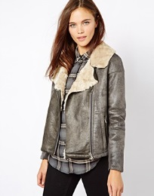 …………………………………………………………………………………

Wendy Sarah …………………………………………………………………………………

  …………………………………………………………………………………

Kipper Austin …………………………………………………………………………………

  …………………………………………………………………………………

Peter Brad …………………………………………………………………………………